Handout #03:
Rank Insignia Recognition Chart
Updated: 25 MAR 18 UNRESTRICTED

Colour: Note that all battle dress rank insignia is black, with the exception of Second Lieutenant and Major which are either brown or green. This is because all other officer ranks when worn on dress uniforms are silver, whereas Majors and Second Lieutenants insignia is brass, as are all Non-Commissioned Officer and Other Rank insignia. In cloth versions white stands in for silver, and yellow for brass.
Note that when writing rank abbreviations in any UNMC document, they MUST be capitalised, as shown.
At left is an image of the rank insignia, followed by the title, then its abbreviation and any notes. Ranks are illustrated in descending order of authority.
The rank of First Sergeant (3 stripes, 3 rockers, and a diamond) is an appointment, being concerned with unit administration.
Commissioned Officers
 | General of the Marine Corps | GMC
 | General | GEN
 | Lieutenant General | LTGEN
 | Major General | MGEN
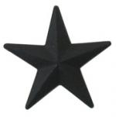 | Brigadier General | BGEN
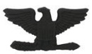 | Colonel |  | COL
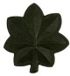 | Lieutenant Colonel |  | LTC
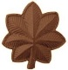 | Major [brass, brown or green] |  | MAJ
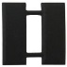 | Captain |  | CPT
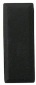 | First Lieutenant |  | 1LT
 | Second Lieutenant [brass, brown or green] |  | 2LT
Non-Commissioned Officers (NCO)
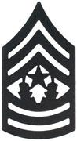 | Command Sergeant Major | CSM
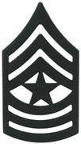 | Sergeant Major | SM
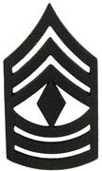 | First Sergeant | 1SGT
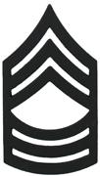 | Master Sergeant | MSGT
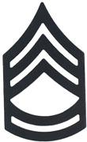 | Sergeant First Class | SFC
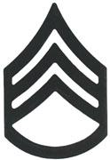 | Staff Sergeant | SSGT
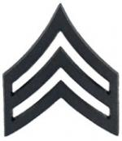 | Sergeant | SGT
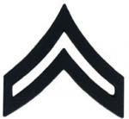 | Corporal | CPL

Other Ranks
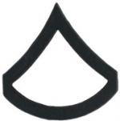 | Private First Class | PFC
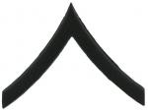 | Private | PVT aka PVT2
NO INSIGNIA | Private | PVT aka PV1 or "Recruit"
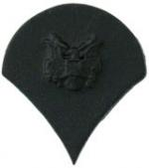 | Specialist | SPEC#
NO INSIGNIA | Very Important Person | VIP#
NO INSIGNIA | Civilian | CIVI#
For more in depth explanations see the pages on Rank & Insignia .
END OF DOCUMENT

